PICAP Final report

Brendan Bickford

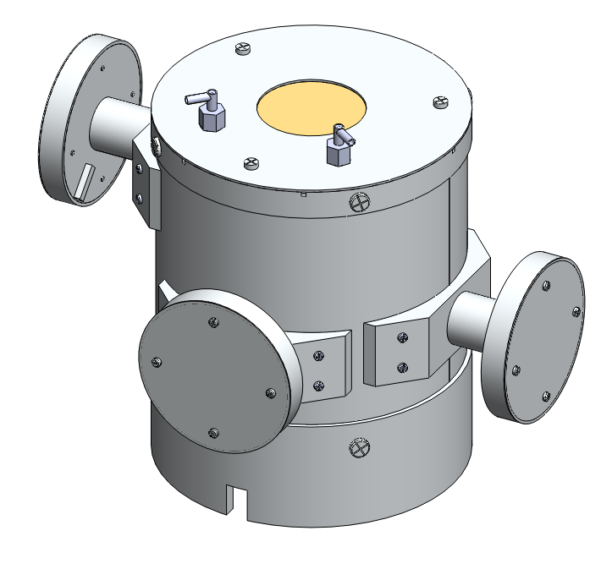

Contents

Executive Summary 4

Introduction 4

Design Criteria 5

Design process 6

Photon detection and Scintillation material 6

Driving Dimensions 6

Solid state detectors 1-3 7

C plastic Scintillator 8

Teflon 10

G crystal scintillator 11

Anti-Coincident scintillator 13

Solid state detectors 4 16

Full assembly 18

Future work 21

Test plan 21

Mechanical Design constraints 21

Test procedure 21

Light leaks 21

Cross talk 22

Particle accelerator 22

PICAP Procedure 23

1. Sub assemblies 24

S1. PMT sub Assembly 24

S2. PMT Mushroom sub-assembly 26

S3. Base Sub Assembly 28

S4. Aluminum cylinder sub-assembly 30

2. Scintillator Assembly 32

2.1 C scintillator sub-assembly 32

2.2 Side PMT 33

2.3 G scintillator sub-assembly 35

2.4 PMT sub-assembly 38

3.0 Side Anti-Plastic assembly 41

4.0 Top Anti Plastic assembly 44

5.0 Top Circuit board assembly 47

5.0 Cover assembly 49

5.1 Column assembly 50

5.2 Top cover assembly 52

6.0 Adding cover to full assembly 54

7.0 Outer Cylinder assembly 56

8.0 Bottom cover assembly 59

8.1 Bottom anti - Scintillator sub assembly 60

8.2 D4 sub assembly 62

9.0 Brass foil assembly 64

10.0 Side PMT assembly 66

12.0 Mushroom plate assembly 68

13.0 Side PMT Circuit board assembly 70

Analysis 71

Absorption probability 72

Venting analysis 74

Thermal Analysis of PICAP 76

Study Properties 77

Study Results 79

Conclusion 81

Hand calculations 81

Frequency analysis of PICAP 82

Study Properties 82

Study Results 84

Conclusion 85

References 86

Quotes 87

Critical design review presentation 87

Next steps 87

# Executive Summary

The goal of this project is to prove a new method for identifying moderate energy positrons and negatrons by building working prototype space flight instrument. This is a comprehensive report of the current mechanical design for the PICAP instrument. In this report the design process is explained out in detail. This design process explains reason behind the design of this instrument to ensure a working and practical instrument. The PICAP Assembly procedure is also included in this report for step by step instructions for the assembly process. Main considerations that were taking into account when designing this instrument were; Machining and Assembly of the instrument, Minimizing weight while keeping rigidity, Keeping cost of building the instrument relatively low, having practical design alterations to make this a full space instrument and Providing sufficient and accurate particle measurements.

# Introduction

This new instrument idea proposed by Dr. James Connell, is new method for detecting moderate energy positrons and negatron in space. The Current method for measuring these particles is by using a magnet spectrometer. Magnet spectrometers typically weigh greater than 10 kg, use more than 10 watts of power and require a magnet. The goal of the proposed PICAP design is to improve on these specifications and provide an alternative and more attractive space flight instrument. The PICAP proposal estimates the instrument to have a weight less than 4 kg, power draw of less than 3 Watts and no magnet required. As a space flight instrument these specifications would make the PICAP instrument a much more desirable alternative.

The PICAP instrument works by using the dE/dx method versus residual energy technique to detect particles. Particles will cross various solid state detectors and deposit their residual energy into a scintillation material. Positrons that ionize in the scintillation material will annihilate and produce two 511 keV photons. These photons will be detected by multiple crystal scintillators surrounding the central scintillation material. Unwanted particle data will be neglected by using scintillation material all around the instrument along with a large solid state detector at the bottom of the device.

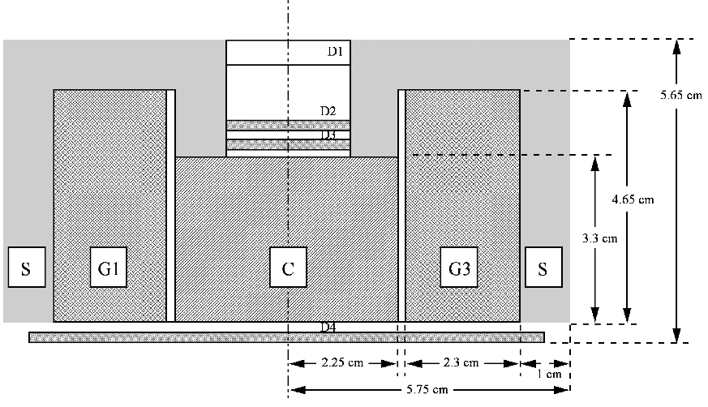

**Figure 1: Cross section of proposed instrument**

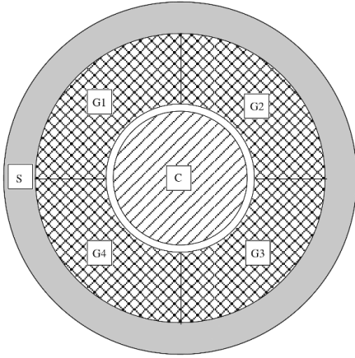

**Figure 2: Top view of proposed instrument**

Figure 1 and 2 show the proposed instrument design. D1,D2,D3 and D4 are the solid state detectors, C is the center plastic scintillation material. G1,G2,G3, and G4 are the crystal scintillation material and S is the surrounding plastic scintillation material called the Anti-coincident.

# Design Criteria

The goal for this project is to make a practical working prototype for the space flight instrument. In order to design this, many aspects had to be considered in the design process. Since this method has not been tested yet, it would be very impractical, due to the high cost, to design a complete space flight instrument to test. This design focuses on making an instrument that would be comparable to a full space ready instrument but at a much lower cost.

The most important aspect of this design was to ensure that particle detection would be an accurate reflection of a space flight instrument. This became fairly difficult when trying to keep the cost of the instrument relatively low. To keep the cost low and the assembly process reasonably easy, the components of the device were made as simple as possible. This would not be the case in the space flight instrument where mass and rigidity would far outweigh the machining and assembly cost. These simple parts make the instrument larger than the space flight instrument and put more material where less is preferred. In some cases the extra material will have adverse effects on the particle detection which are taken into consideration with the prototype. Currently, simulation runs with the Monte Carlo program EGS4 are being performed to ensure the existing design will be meet the particle detection requirements .

# Design process

## Photon detection and Scintillation material

The Center and Anti-coincident scintillators are required to be made from plastic in order to ionize the particles within our given energy range. This means that a photomultiplier tube is our only option to detect scintillation since the resolution of a photodiode would not suffice. With this in mind, a practical photomultiplier tube for this instrument had to be used. This photomultiplier tube had to be ruggedized for use in space flight and preferably the smallest size possible. For this design the model R3991-04, from [Hamamatsu Photonics](http://www.hamamatsu.com/) was chosen. This tube became one of the driving dimensions of the design.

The material for the G scintillation crystal was proposed in the design as cesium iodide. However, other materials for these scintillators were researched under two requirements; the material must be hydroscopic to ensure atmospheric water doesn't affect the crystal and that it must have equivalent or better probability of absorption than that of the proposed design, It was found that [bismuth germanate](http://en.wikipedia.org/wiki/Bismuth_germanate) would be a better substitute. Calculations show that [bismuth germanate](http://en.wikipedia.org/wiki/Bismuth_germanate) would save mass while still having the same absorption probability of annihilation photons as cesium iodide. For the same absorption probability only .9353 cm [bismuth germanate](http://en.wikipedia.org/wiki/Bismuth_germanate) would be needed compared to the 2.3 cm of cesium iodide. The decision was made to change the material based on the ability to make the entire size of the device smaller.

## Driving Dimensions

The driving dimensions for this design became the size Center plastic scintillator, the size of the G crystal scintillators, the use of Teflon around each scintillator, the size of the 4 solid state detectors, and the size of the photomultiplier tubes. Once the size requirements that would provide efficient and accurate particle measurements for each of these parts were determined, the rest of the telescope was designed around them.

### Solid state detectors 1-3

The three solid state detectors at the entrance to the device drive both the dimensions for the window opening at the entrance of the telescope and the size of the C scintillator. The dimension that will affect the size of the window and C scintillator is the total width of the column assembly that hold the solid state detectors in place. This column assembly was designed as a way of housing the solid state detectors securely in place, while providing a path for the lead wires and providing a safe assembly procedure to protect the valuable solid state detectors.

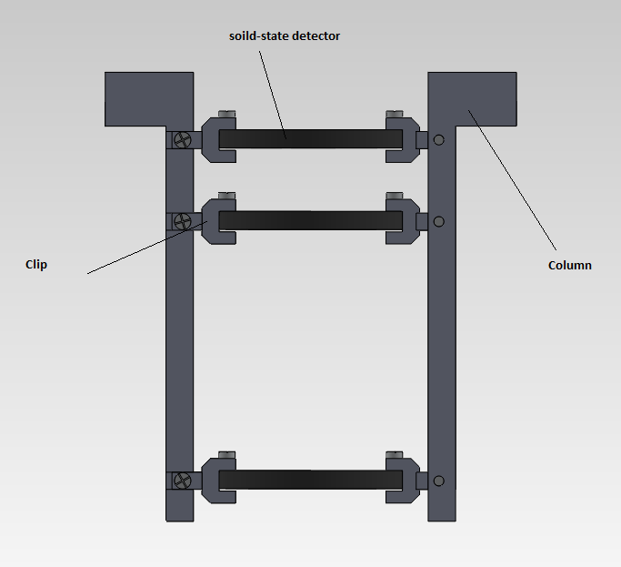

**Figure 3: cross section of column assembly**

Figure 3 shows a cross section of the column assembly. Only two solid state detectors are shown because the third is arbitrary and will be placed wherever the best fit for energy measurements is. The other two detectors are placed as close to 5 mm from each edge as possible. The top flaps on each column are screwed in by 4 machine screws to the cap of the instrument. The columns and clips will be machined from delrin.

### C plastic Scintillator

The C scintillator became a huge driving dimension in the design due to the fact it was placed right in the center of the telescope. The size of the this scintillator was originally proposed to have a radius of 2.25 cm but this had to be changed due to considerations of various particle paths. In order for the instrument to measure energy loss properly, any particle going through the 3 solid state detectors at the opening of the device must proceed to enter the C scintillator. This means at the most extreme angle, the particle will enter the edge of the active area on the top solid state detector, continue to the opposite bottom edge of the active area of the bottom solid state detector and continue into the C scintillator. This is shown in figure 4.

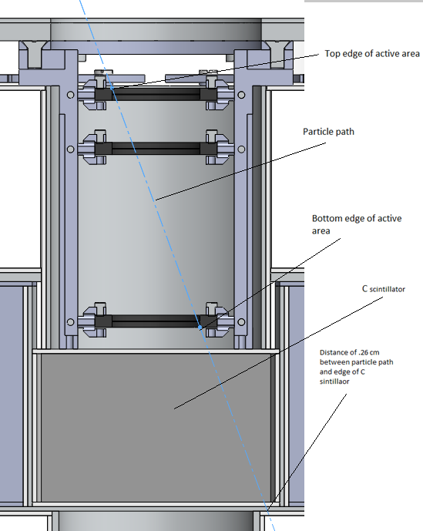

**Figure 4: Extreme angle of particle entry**

Figure 4 shows the extreme angle entry for a given particle, as shown the C scintillator was designed to account for this path. This extreme angle does not account for scattering particles that could still leave energy in the top solid state detectors and not enter the C scintillator, however at this time it is believed this design will suffice and will be confirmed when simulation runs with EGS4 are concluded. The C scintillator also must be coated all around with Teflon so that light created by the particle will bounce around till it can be read by the photomultiplier tube. This also means that the C scintillator cannot be made as a full 360 degree circle since the photomultiplier tube must be adhered to one side.

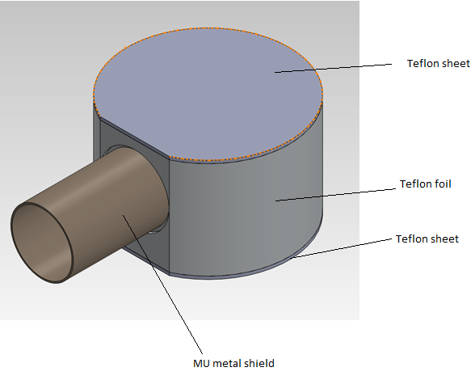

**Figure 5: Isometric view of C scintillator covered in Teflon with attached MU metal shield**

### Teflon

In this design Teflon needs to coat each scintillator on all sides. In order to do this smooth Teflon in 1mm thick sheets were used for the top and bottom of each scintillator and 1.016 mm (.04 inch) foil that could be wrapped around was used to surround the side of each scintillator. In ordered to increase the reflective properties of the Teflon, the Teflon will be scuffed up to roughen the surface.

Teflon has been quite difficult to design around due to the fact that it needs to be flush around all sides of each of the scintillators. Since the scintillators do not have uniform shapes and there is no way of adhering Teflon, extra structural support is needed to support the Teflon. This extra structural support adds unwanted mass but is required.

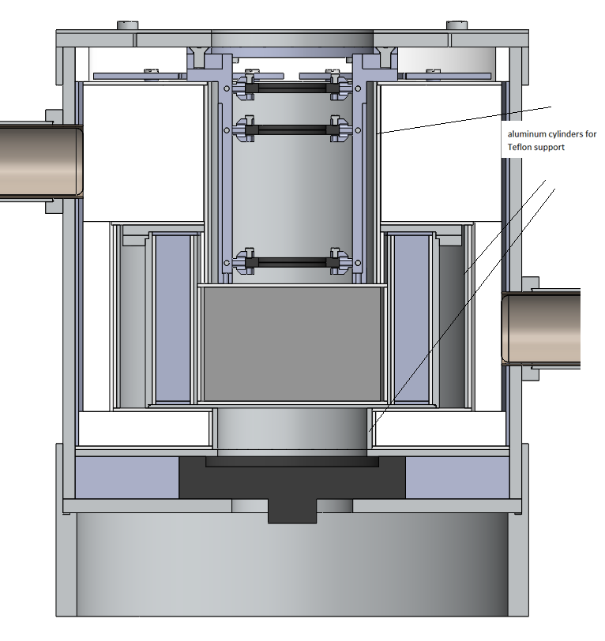

**Figure 6: cross section showing extra support for Teflon**

### G crystal scintillator

As shown with calculations, the minimum required size for the G crystal made from [bismuth germanate](http://en.wikipedia.org/wiki/Bismuth_germanate) was found to be .9353. Referring to figure 2: Top view of proposed instrument, it is shown that [bismuth germanate](http://en.wikipedia.org/wiki/Bismuth_germanate) is 360 degrees around surrounding the center scintillator. This means [bismuth germanate](http://en.wikipedia.org/wiki/Bismuth_germanate) is being driven by the size of the C. Knowing the required dimensions for C from the extreme angle entry, a structure was designed to house the G and C scintillator along with their respective Teflon and Photomultiplier tubes.

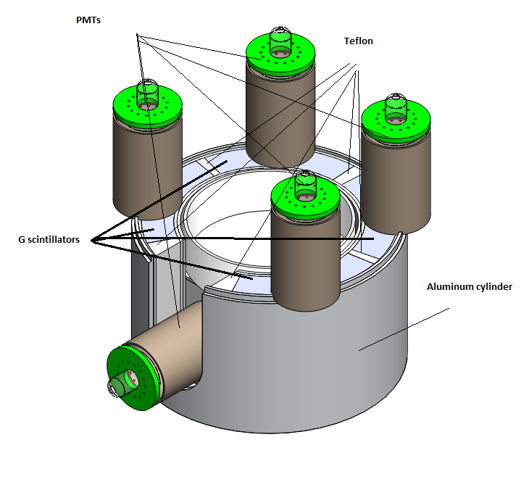

**Figure 6: Housing for C and G scintillator**

This housing design shows two thin walled tube aluminum cylinders that will hold all components inside stable. A bottom plate (not shown) will be adhered to the outer cylinder as a base. This will be adhered rather than machined in order to keep the parts simple and cheap. This is the same with the flanges that are holding the photomultiplier in the vertical direction. It would be necessary to make these one piece in the space flight instrument, but for the prototype, adhering these pieces will suffice.

Currently the inner cylinder in modeled at a 1mm thickness. To provide the best particle detection, this needs to be as thin as possible. For a practical prototype this 1mm thickness was decided on based on the thinnest aluminum could be machined within a reasonable budget. For the actual space flight instrument this will be made thinner and with titanium to ensure the best energy measurements and to save mass.

This assembly also includes, but does show, a layer of Teflon over the top of the G scintillator and an aluminum cover that is screwed in by 4 machine screws.

### Anti-Coincident scintillator

The Anti-Coincident scintillator is designed to detect particles that will not be measured properly. In order for this telescope to accurately detect positrons and negatrons, energy must be deposited in the three solid state detectors and the C scintillator. Therefore this scintillator is designed to detect particles that enter the telescope from any direction other than the front window so they can be excluded from analysis. In order to ensure the anti-coincident efficiently measures all particles that enter from varies directions, it was attempted to make this scintillator at least 1cm thick in all areas where particles could enter the device and not trigger all three of the top solid state detectors and the C scintillator.

Due to the size of the solid state detectors and their support columns, 1 cm of thickness cannot be attained with the current size of the C and G scintillator. Figure 7 and 8 show areas where 1cm thickness has not been attained. It was decided that before altering the design of the C and G scintillators, simulation runs with the Monty Carlo program would be performed in order to confirm whether or not the current design will suffice.

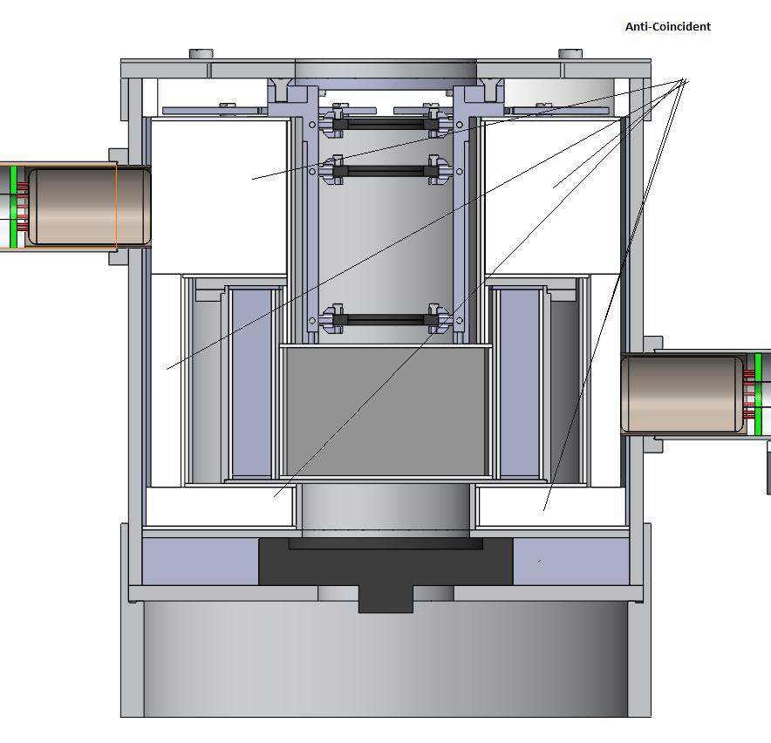

**Figure 8: Section view, Anti scintillator**

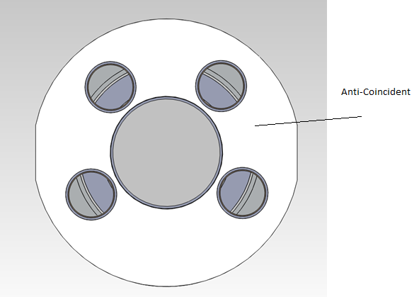

**Figure 9: Top view, Anti scintillator**

Modification to the current Anti-Coincident must also be made in order to place and secure circuit boards for each photomultiplier tube. Once confirmation has been made through simulation runs that this overall design is acceptable, an allowable board size can be determined and made for the electronics of the photomultiplier tubes.

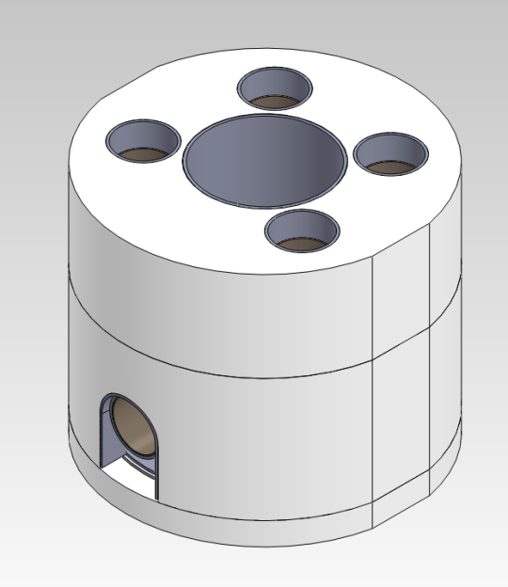

**Figure 10: Isometric view Anti scintillator**

### Solid state detectors 4

The purpose of solid state detector 4 is to detect heavy particles that enter the instrument from the window. If a particle is able to trigger the top three solid state detectors and continue all the way through the C scintillator, it is out of the energy range the instrument is designed to identify. In order to prevent these heavy particles from falsely being identified by as negatrons, D4 is placed at the bottom of the instrument so that if D4 is triggered the detection will be ignored. Figure 11 shows D4 and a particle path within the telescope. Figure 12 shows the housing assembly for D4.l

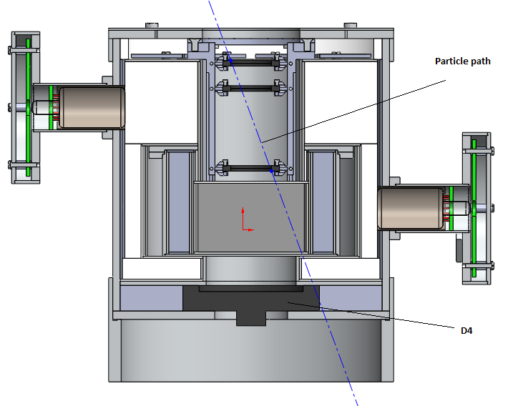

**Figure 11: D4 and particle path**

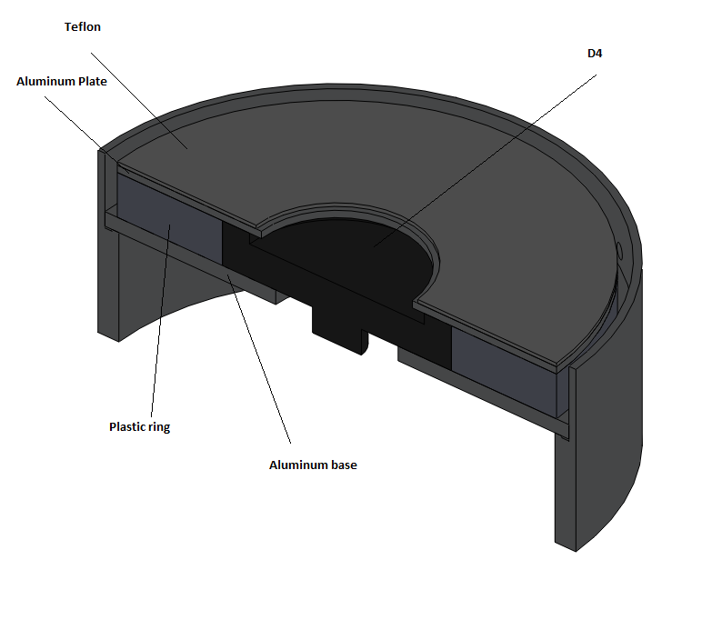

**Figure 12: D4 housing**

## 

## Full assembly

Figure 13 and 14 show the current full assembly of the telescope. Some design alterations that have to be made are talked about in the future work section.

# 

**Figure 13: Full assembly**

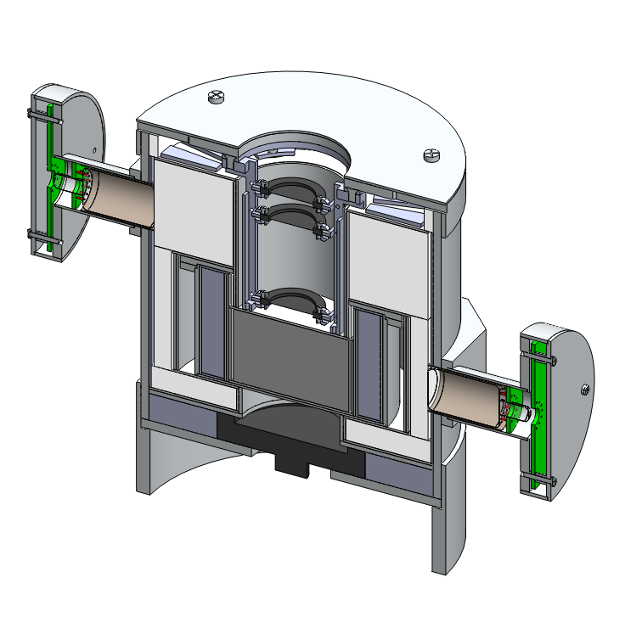

**Figure 14: Full assembly section view**

# Future work

Currently as of 5/01/12 parts are being fabricated at stone machine in Chester. Once all parts are Finished the future work includes assembly and testing.

# Test plan

## Mechanical Design constraints

Light leaks - In order to provide efficient particle detection, ambient light outside the telescope must not be seen by any of the photomultiplier tubes.

Cross talk - When light is seen by any given scintillator, the same light should not be read by any other scintillator.

## Test procedure

For all procedures, the photomultiplier tubes and solid state detectors will be powered by a high voltage power supply. The output signal will be amplified by a pre amplifier amp into a amplifier and read by an oscilloscope and multichannel analyzer.

### Light leaks

To test for light leaks we will place the telescope in a well lit room and record the output signals. After the output signals are recorded, the lights will be shut off and a black velvet sheet will be placed over the telescope in order to block all incoming light. If the instrument is properly light proof, these signals should not significantly change.

### Cross talk

To test for cross talk between scintillators, an Alpha ray source will be culminated towards a single scintillator. If the scintillator is properly light tight, the only photomulipler tube that will produce a signal will be the one on that scinillator.

### Particle accelerator

Once the PICAP Instrument is finished, It will be brought to the Mass General Hospital proton beam and Idaho State cyclotron to be tested.

# Testing solid-state detectors

Solid-state detectors are a vital part of the Picap instrument. The Picap uses four solid-state detectors to detect and help identify particles that enter the front of the telescope. Electrons can be distinguished from more massive particles of the same total energy by their much lower dE/dx which generates no trigger in D1 and small signals in D2 and D3. Relativistic protons will produce a dE/dx signature similar to an electron but will also trigger D4. The purpose of testing these solid-state detectors is to determine the intrinsic noise produced by the detectors.

These solid-state detectors are also known as Semiconductor Radiation Detectors. These detectors use a semiconductor material, in this case silicon, as a detecting medium. These detectors are made by [doping](http://en.wikipedia.org/wiki/Doping_(semiconductor)) narrow strips of [silicon](http://en.wikipedia.org/wiki/Silicon) to make them into [diodes](http://en.wikipedia.org/wiki/Diode), which are then [reverse biased](http://en.wikipedia.org/wiki/P-n_junction#Reverse_bias). When a particle passes through the detector it will cause an ionization current which can be measured. The current measured can be used to determine the energy of the particle passing though. The intrinsic noise of the detector must be found to ensure the measured current is a correct correlation of the energy in the passing particle.

To test these detectors, an alpha radiation source, Americium-241, was columned towards the detector and the resulting signal was measured and recorded. The data recorded was then analyzed to fit a Gaussian curve which was used to calculate the intrinsic noise of the detector.

## Procedure

Four different solid detectors were tested to find the intrinsic noise.

|  |  |
| --- | --- |
| Solid-State detector | Thickness (µm) |
| 43-012B | 50 |
| 43-014B | 1000 |
| 43-014D | 1000 |
| 51-098C | 1000 |

### steps

1) The solid state detector was placed in a mounting fixture inside a vacuum chamber where the alpha source could be collimated towards the detector and bias leads could be attached.

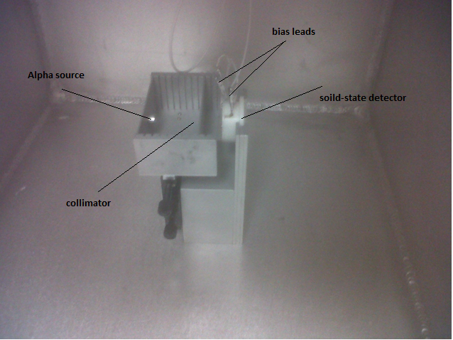

2) The bias leads from the detector were wired into a preamp which was wired to an amplifier, and wired to be powered by a power supply.

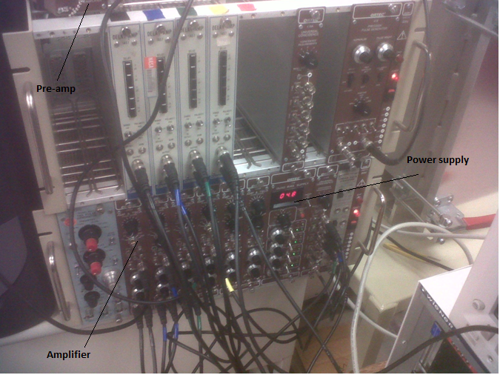

3) The signal from the amplifier was wired into an oscilloscope were it could be measured and wired to a multi-channel analyzer where the output signal could be recorded.

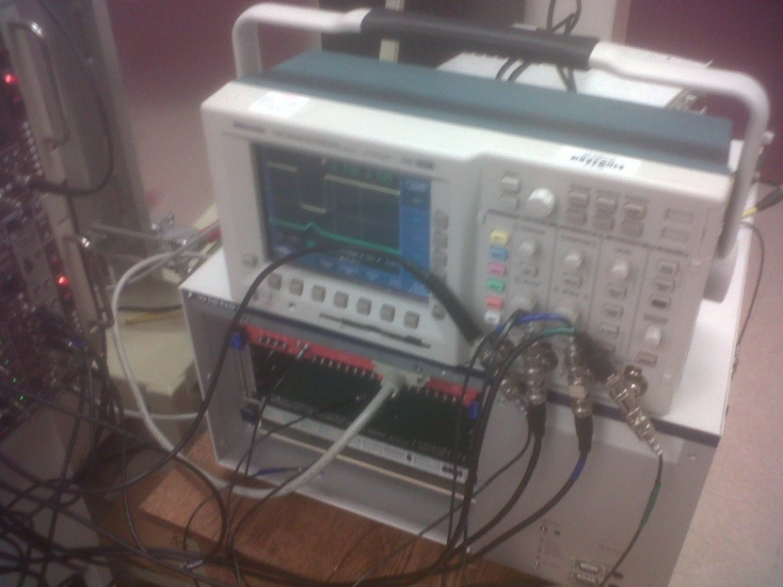

4) Once the wiring was complete, the gas chamber was closed and pumped down to 50 milil-Torr.

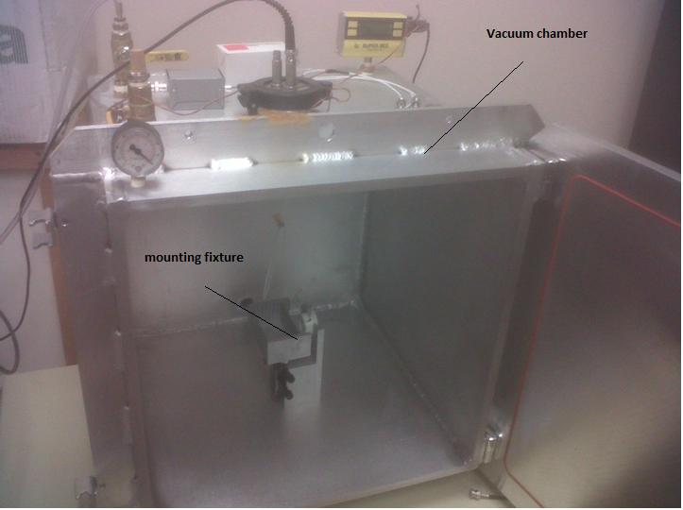

5) After the chamber is pumped down to at least 50 milil-Torr, the bias voltage for the solid state detectors was turned on to the manufactures specification and the output signals each event were recorded by the MCA for at least 10 hours.

## Analysis

To determine the intrinsic noise produced by the detector, first a Gaussian curve was fitted to the data recorded by the MCA. With this Gaussian curve both standard deviation and mean values could be determined based on the formula;

$$y\left(x\right)=y_{0}+Ae^{(-\frac{{\left(x-μ\right)}^{2}}{2σ^{2}})}$$

where $y_{0}$ is the initial amplitude, A is a constant, x is the number of events, $μ$ is the mean value and σ is the standard deviation. The initial amplitude is equal to 0 because in channel one, it is assumed to have 0 energy.

Knowing that the MCA takes linear measurements, the energy per channel can be calculated by taking the known peak energy produced by the Americium-241 source and dividing by the mean of distribution.

$$E_{c}=\frac{E_{Am-241}}{μ}$$

The total energy associated with the standard deviation was than calculated by;

$$σ_{total}=σ*E_{c}$$

Due to the housing of the Americium-241 source, there is a slight energy loss through the titanium window that must be accounted for. This value was giving by the manufactures specification at 80.6KeV.

The standard deviation of the energy measured from the solid-state detectors was then calculated by;

$${σ_{total}}^{2}={σ_{ssd}}^{2}+{σ_{AM-241}}^{2}$$

$$σ_{ssd}=\sqrt{{σ_{total}}^{2}-{σ_{AM-241}}^{2}}$$

# PICAP Procedure

This is the design review assembly procedure for the PICAP telescope.

The purpose of this assembly procedure is to provide a basic visual aide during the peer review.

Note: The bordered pictures are not steps, these are final pictures of each sub assembly

# 1. Sub assemblies

# S1. PMT sub Assembly

# 

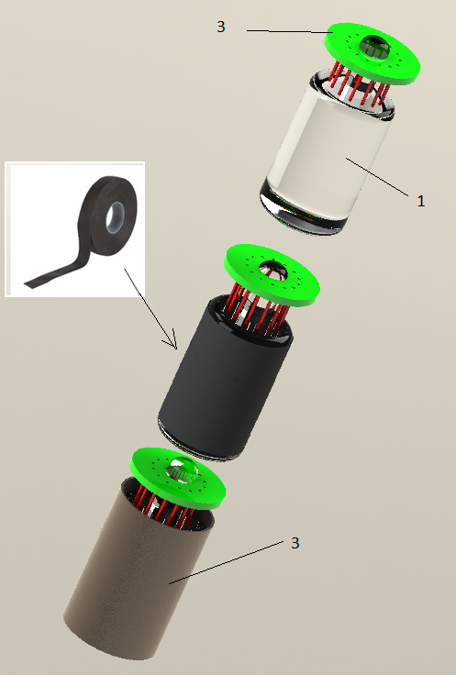

1 Solder daughter board onto PMT leads

2 Friction hold PMT in Mu metal Shield with Black tape

# S2. PMT Mushroom sub-assembly

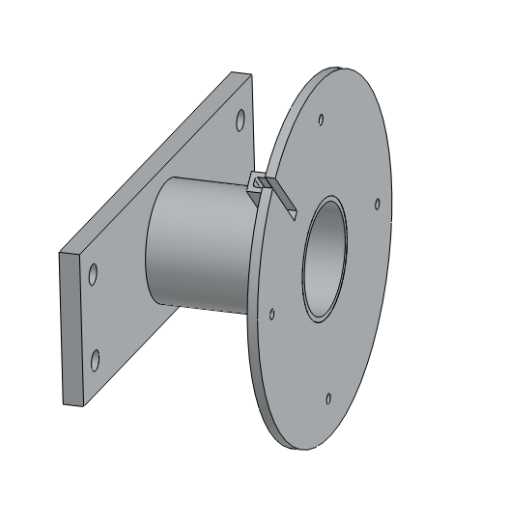

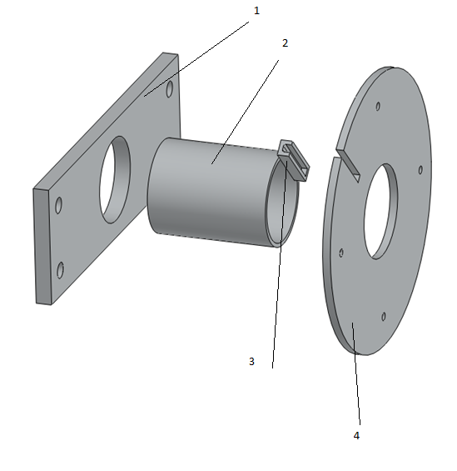

1 Epoxy Wire guard (3) onto circular aluminum base (4)

2 Epoxy Aluminum cylinder (2) into onto circular aluminum base (4)

3 Epoxy Aluminum cylinder (2) into Base plate (1)

# S3. Base Sub Assembly

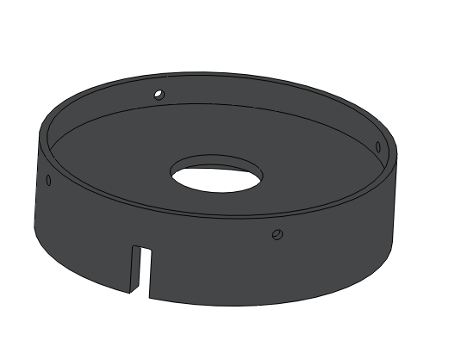

# 

1 Epoxy Circular plate (1) onto the hinge of the base (2)

## S4. Aluminum cylinder sub-assembly

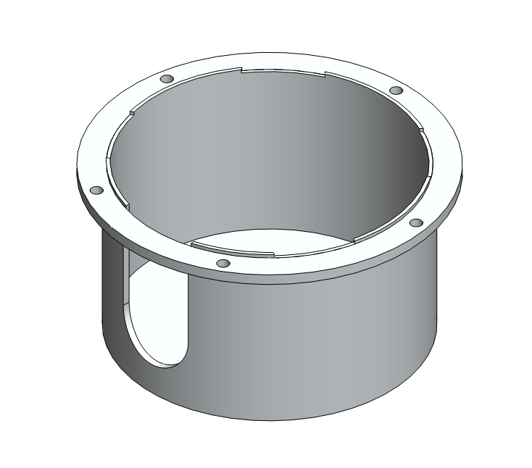

## 

1 Epoxy Aluminum cylinder to bottom plate. let sit until dry.

2 Epoxy flanges onto Aluminum cylinder

# 2. Scintillator Assembly

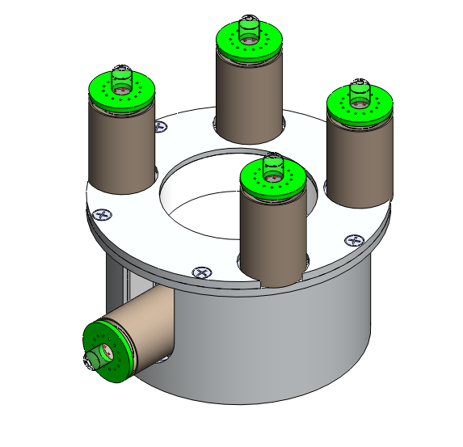

## 2.1 C scintillator sub-assembly

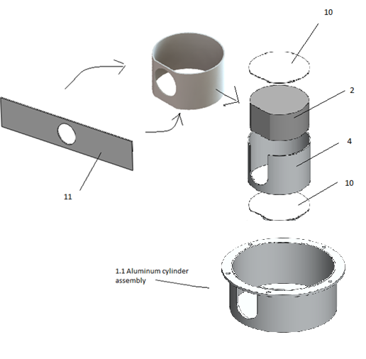

1 Place inner aluminum cylinder (4) into Current assembly

2 Place Teflon (10) into the inner aluminum cylinder (4)

3 Wrap Teflon foil (11) around C scintillator (2) drop into inner aluminum cylinder (4)

4 Place Teflon (10) into the inner aluminum cylinder (4) on top of the C scintillator (2)

## 2.2 Side PMT

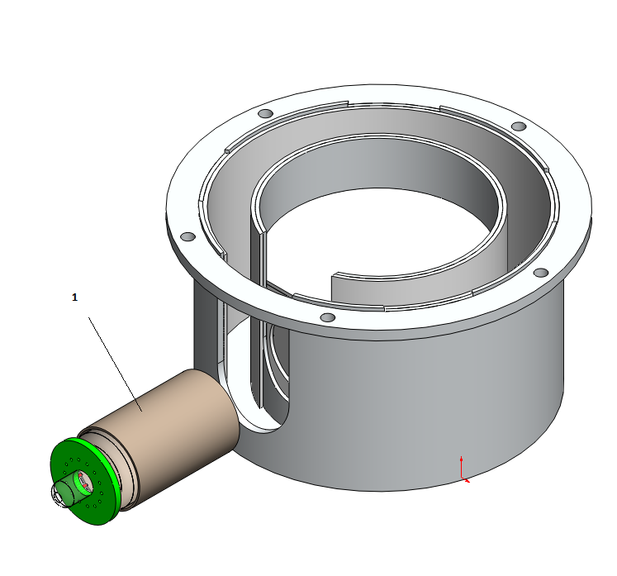

1 PTV PMT assembly (1) onto the C scintillaor through the hole of the Teflon

## 2.3 G scintillator sub-assembly

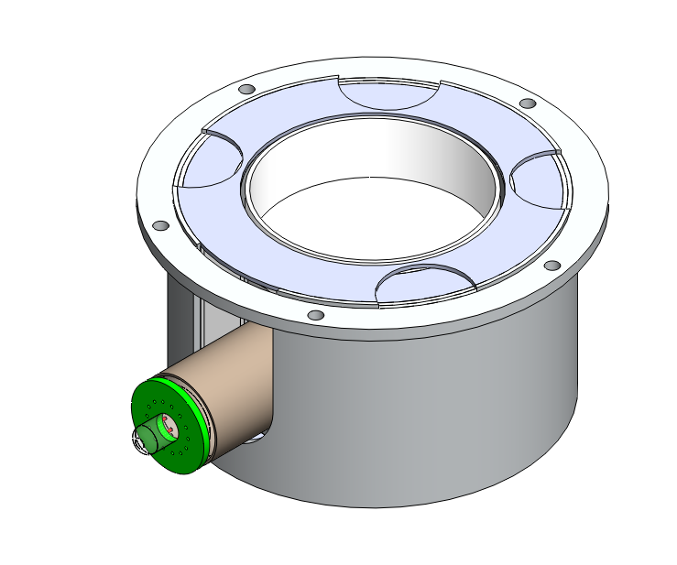

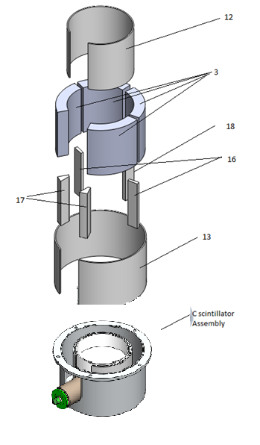

1 Place outer Teflon ring (13) into Current assembly

2 Place G-scintillators (3) into the current assembly between outer Teflon ring (13) and intter aluminum cylinder in the current assembly

3 place inner Teflon ring (12) in-between G-scintillators (3) and the intter aluminum cylinder in the current assembly

4 Place Teflon bars (16,17,18) between G-scintillators (3) in the order given below

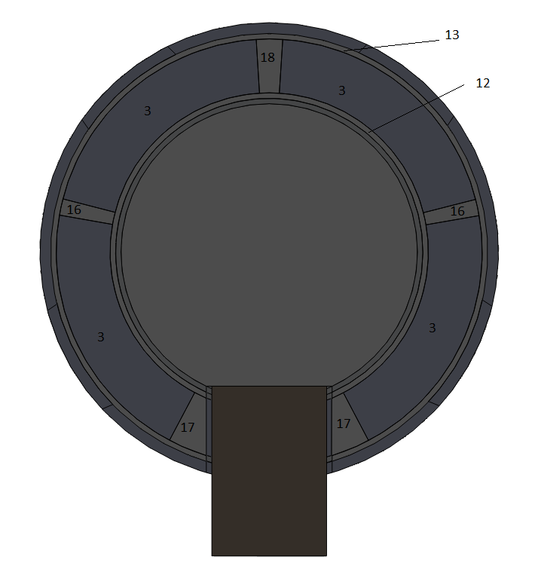

## 2.4 PMT sub-assembly

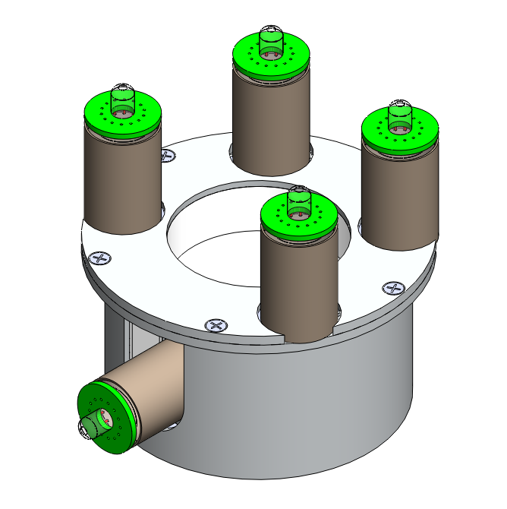

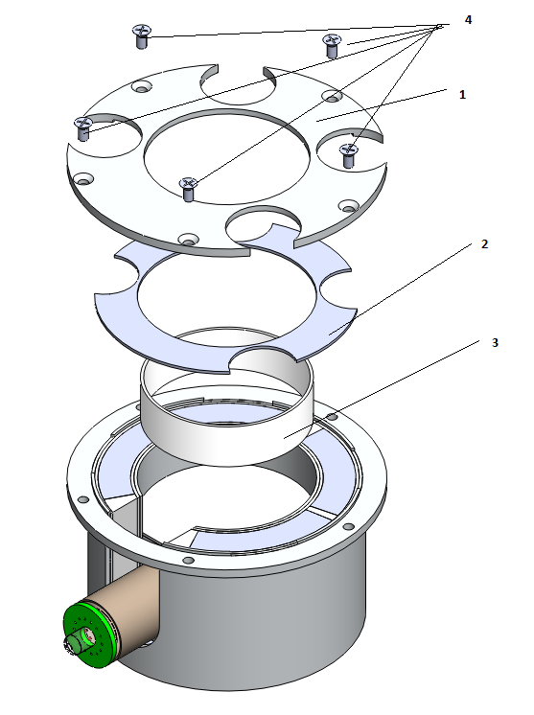

1 Place Plastic support ring (3) in the center of the inner aluminum cylinder

2 Place Teflon cover ring (2) on top of G-sintilators

3 Place Cover (1) on top of full assembly and screw in with M2 screws

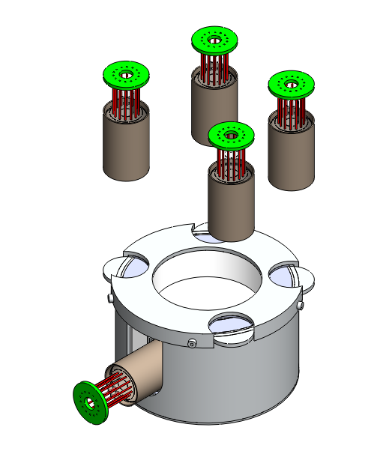

4 PMT assemblies onto G-sintillators

# 3.0 Side Anti-Plastic assembly

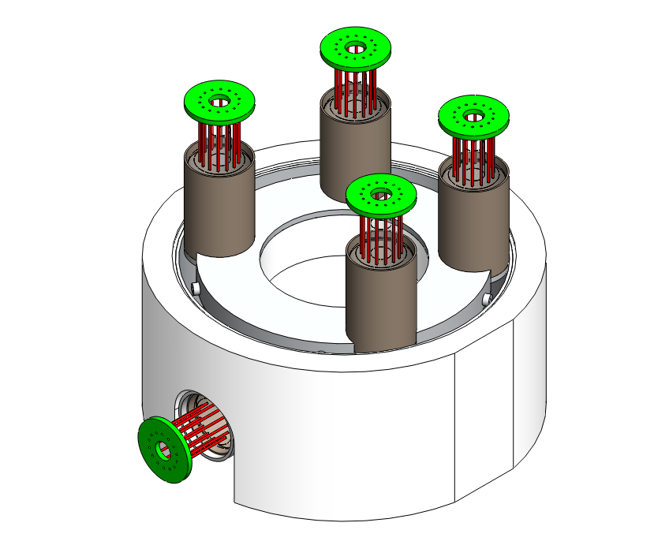

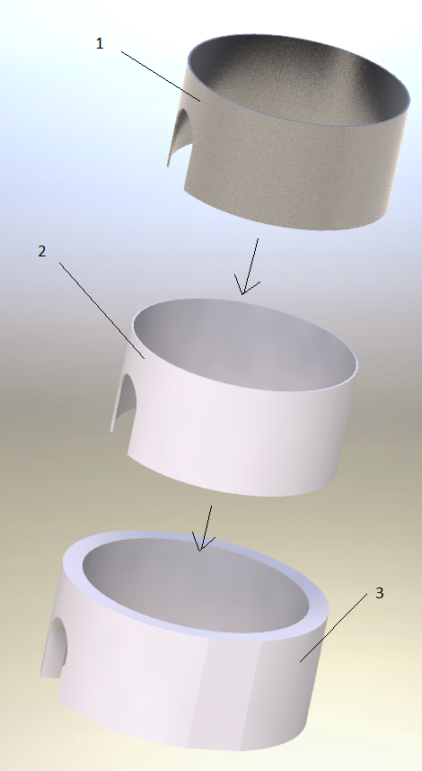

1 Place Teflon ring (2) into Outer Anti Plastic (3)

2 place aluminum cylinder (1) into the center of the Teflon ring (2)

# 

3 Place all 3 pieces around the current full assembly

# 4.0 Top Anti Plastic assembly

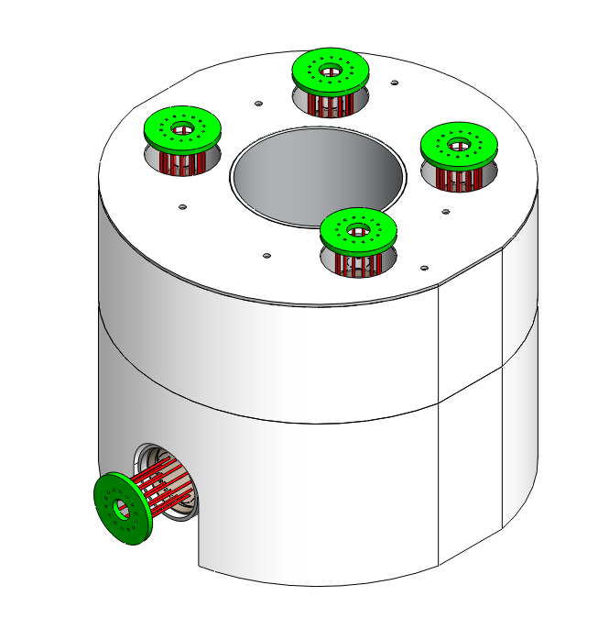

# 

1 Place Teflon cover ring (5) onto the cover of the current assembly

2 Place top Anti plastic (4) onto side anti plastic and Teflon cover ring (5)

3 Place Teflon ring (2) into the center of top Anti plastic (4)

4 Place Aluminum cylinder (3) in the center of Teflon ring (2)

5 Place the four Teflon rings (1) around each of the four mu-metal shields in the top Anti plastic (4)

# 5.0 Top Circuit board assembly

# 

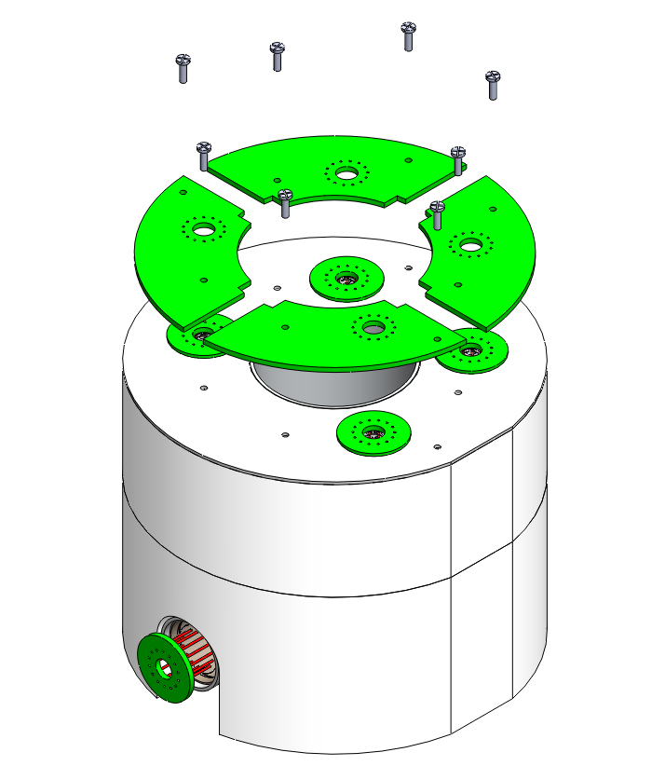

1 Align Pins of mother and daughter circuit boards

2 Align spacers with through holes of mother circuit boards

3 Screw in Circuit boards with Nylon M2 screws

# 5.0 Cover assembly

# 

## 5.1 Column assembly

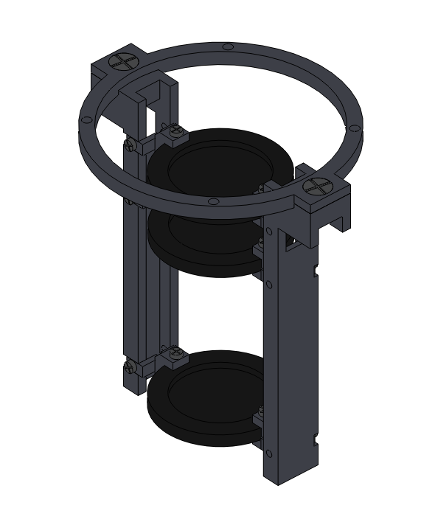

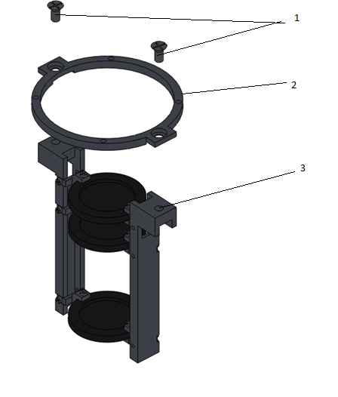

1 Screw aluminum ring (2) onto Column assembly (3) with counter sunk M3 screws (1)

## 5.2 Top cover assembly

# 

# 

1 Screw column assembly (2) onto Cover (3) with M2 screw s (1)

# 6.0 Adding cover to full assembly

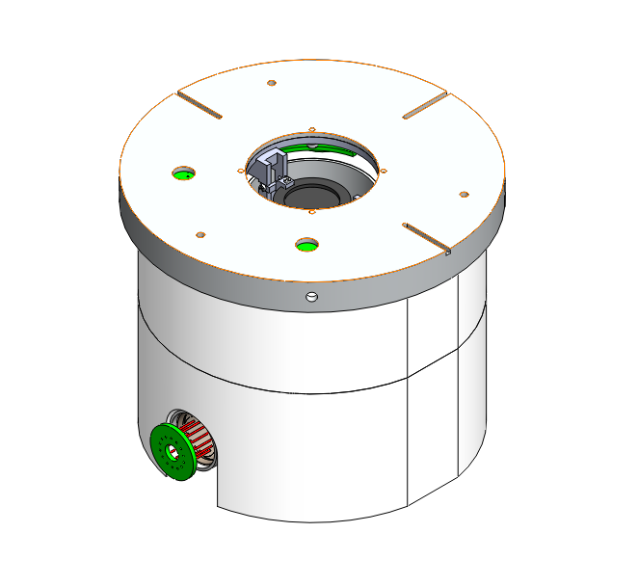

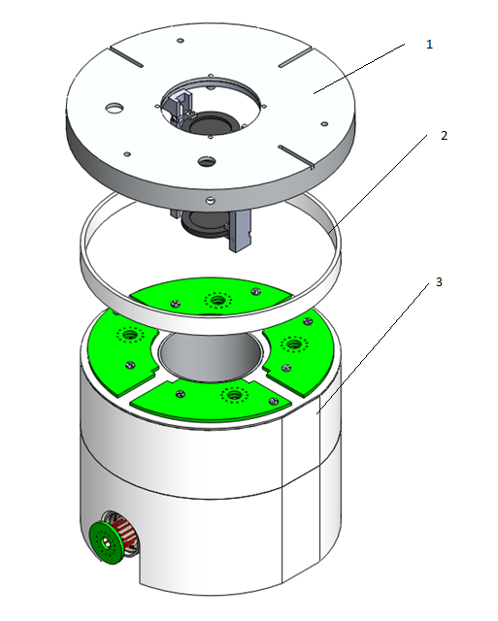

1 Place Plastic place holder ring (2) on top of the Top anit Plastic in the current assembly (3)

2 Place Cover assembly (1) on top of place holder ring (2)

# 7.0 Outer Cylinder assembly

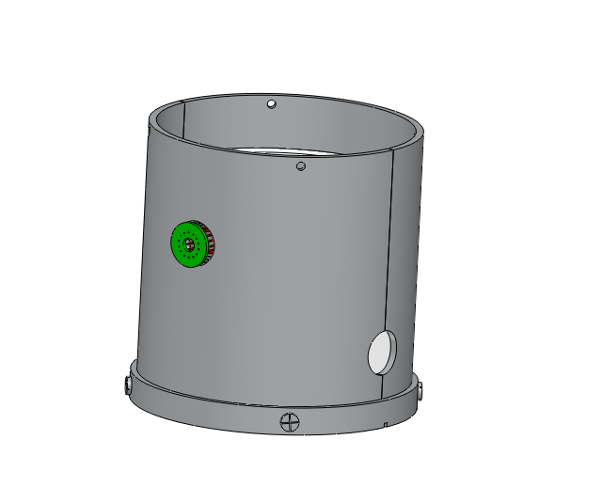

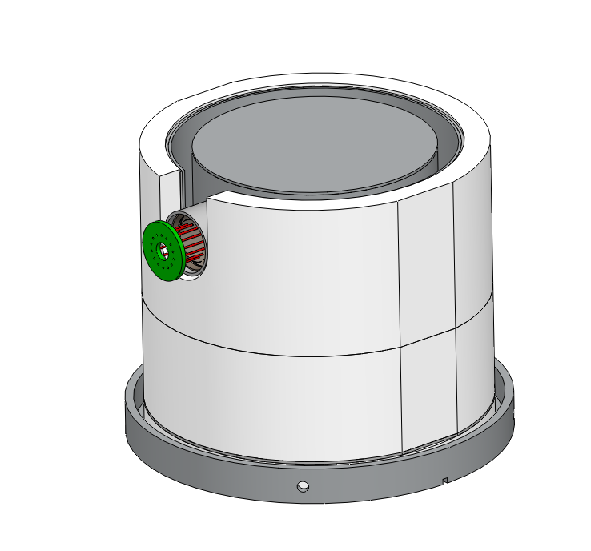

1 Flip entire assembly

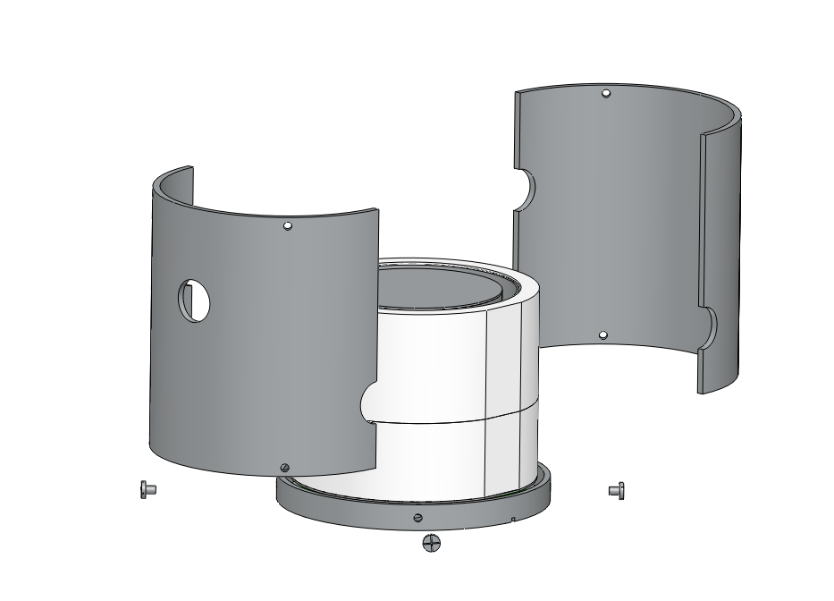

1 Place aluminum Cylinder halves around Anti sintillator and screw with M4 screws

# 8.0 Bottom cover assembly

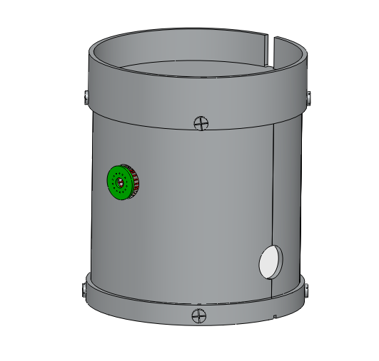

## 8.1 Bottom anti - Scintillator sub assembly

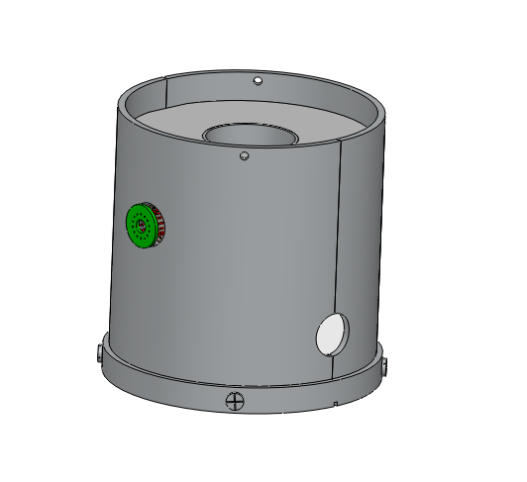

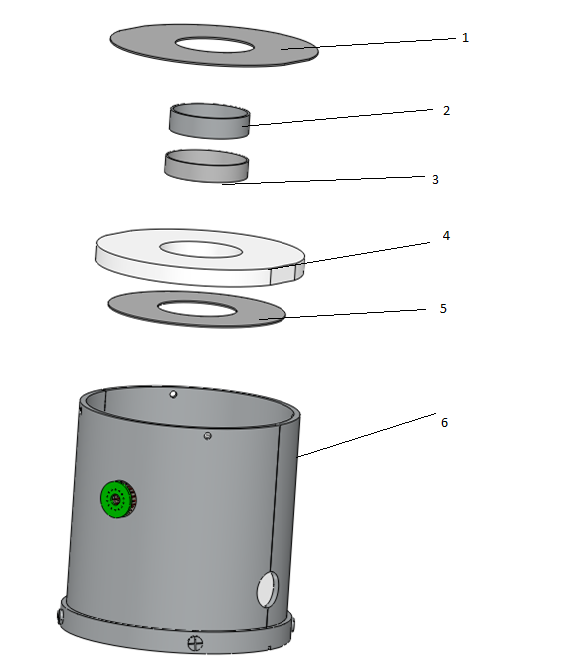

1 Place Teflon Cover ring (5) on the aluminum base in the current assembly (6)

2 Place bottom Anti plastic (4) on the side Anti plastic in current assembly (6)

3 Place the Teflon ring (3) in the center of Anti plastic (4)

4 Place the Aluminum ring (2) in the center of the Teflon ring (3)

5 Place the Teflon Ring cover (1) onto the Bottom anit plastic (4)

## 8.2 D4 sub assembly

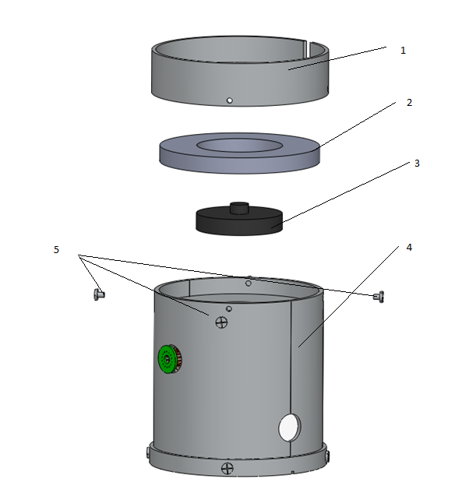

1 Place Plastic ring (2) into the current assembly (4)

2 Place D4 (3) into the center Plastic (2)

3 Place Base Assembly (1) on current assembly and screw with 4 M4 screws (5)

4 Flip whole assembly

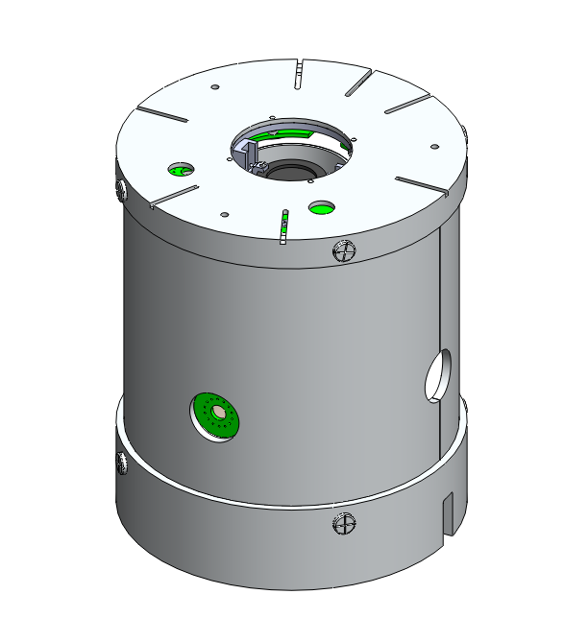

# 9.0 Brass foil assembly

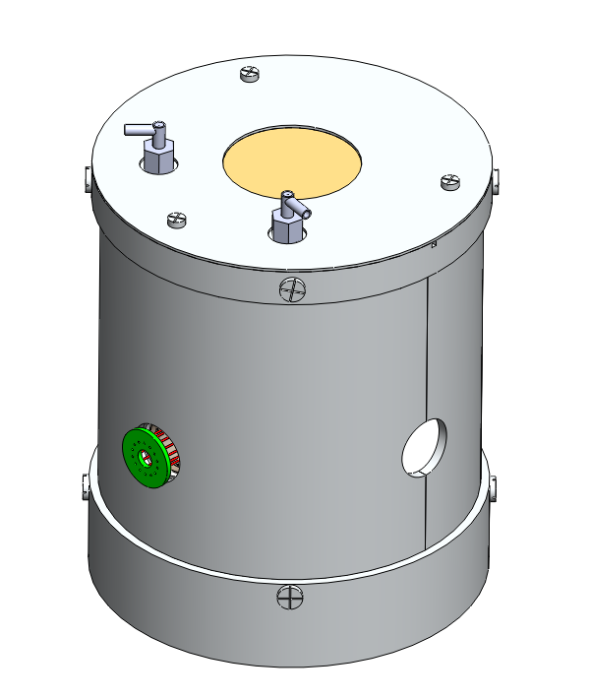

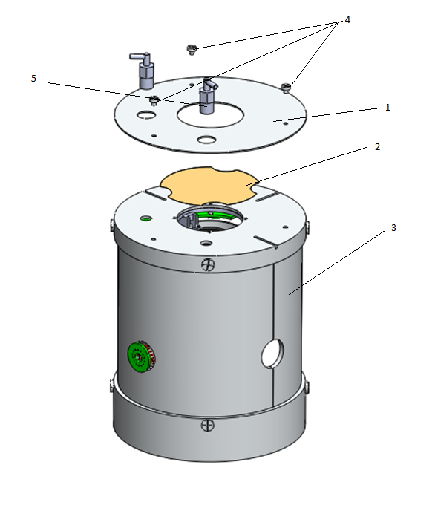

1 Place Brass foil (2) onto the cover of the Current assembly (3)

2 Place the top of the aluminum cover (1) top of the Brass foil (2) and cover of the Current assembly (30 and screw in with M3 screws (4)

3 Screw in the 90 degree vent ports (5) into the cover in the Current assembly (3) (top of the aluminum cover (1) is a through hole)

# 10.0 Side PMT assembly

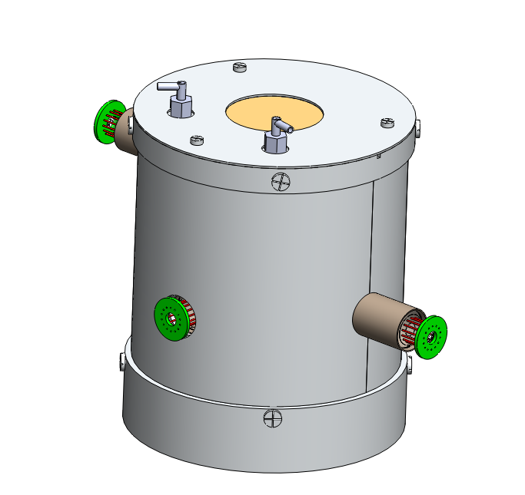

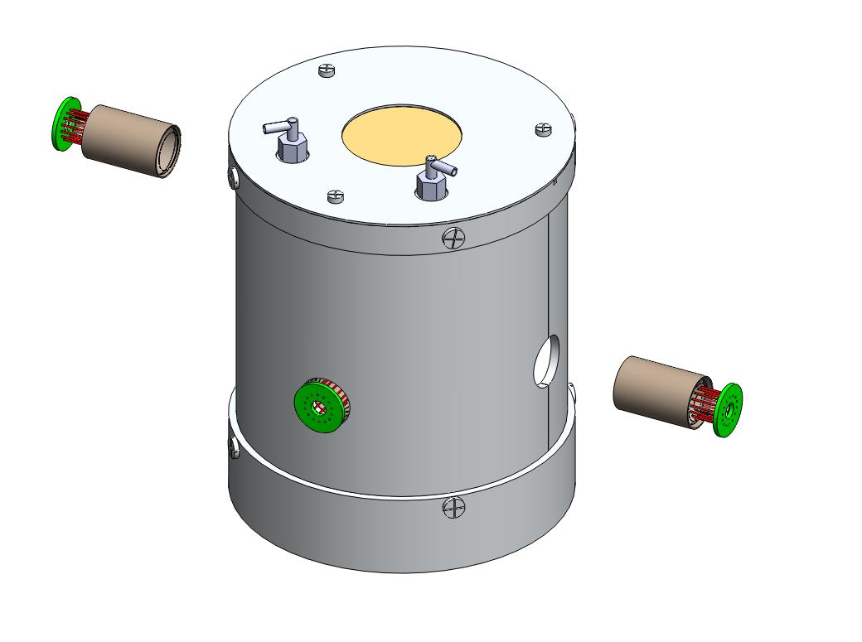

1 PTV The two PMT assemblies to the side of the anti plastic

# 12.0 Mushroom plate assembly

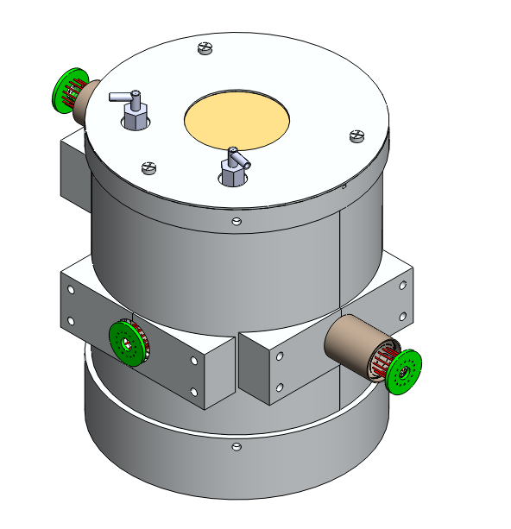

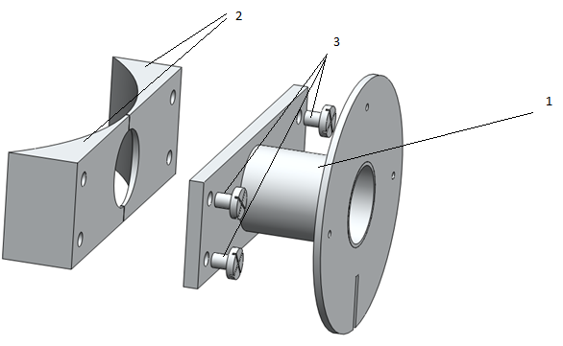

1 Screw Mushroom assembly (1) onto circular bases (2) with M4 screws (3)

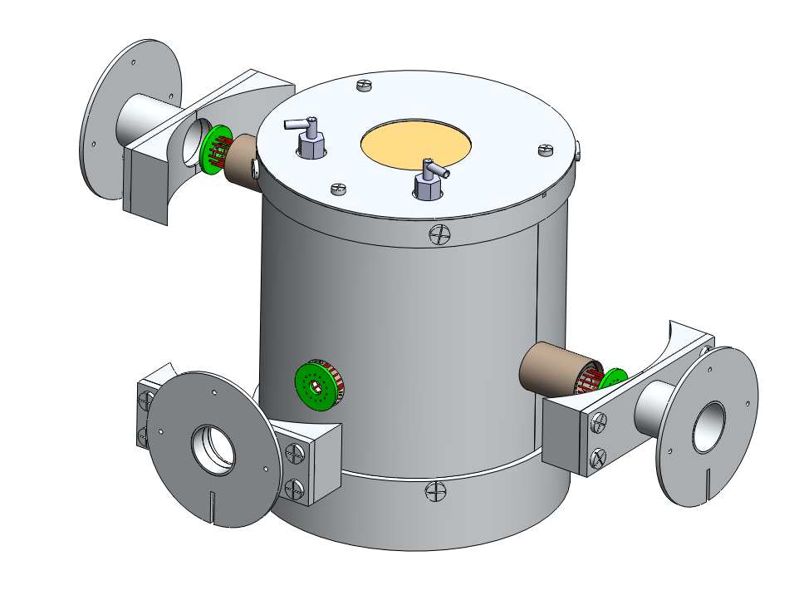

2 Epoxy circular bases onto the cylinder halves of the full assembly

# 13.0 Side PMT Circuit board assembly

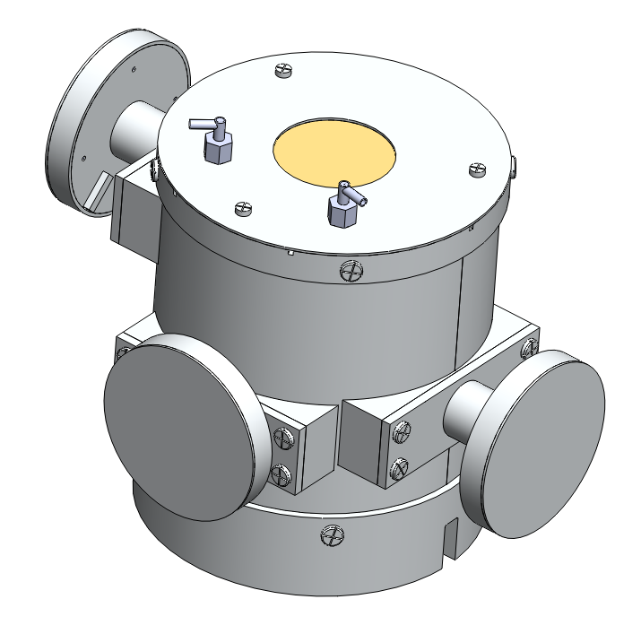

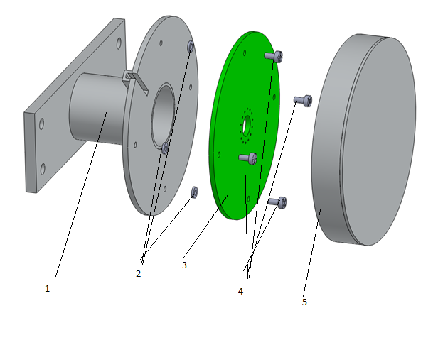

1 Align spacers (2) with through holes in the circuit board (3) and screw in with M2 screws (4)

2 Screw cover (5) onto Mushroom assembly (1)

# Analysis

This section includes analysis for the absorption probability of annihilation photons by the crystal material, a venting analysis, a thermal analysis and vibration analysis for the telescope. The purpose for probability of absorption calculations were to minimize the mass of the telescope while still ensuring efficient and accurate measurements of particles. The venting analysis was to ensure the change in pressure between the inside and outside of the telescope won't have adverse structural effects during launch. The thermal analysis was performed to ensure the temperature will not interfere with instrument's measurements or structural integrity while in orbit and vibration analysis was done to make certain that the telescope will not reach its natural frequency.

Due to the complexity and size of the actual design model, Soildworks was not able to perform computations for analysis. Many attempts were made to use the current state of the design but each time soildworks would fail in simulation for thermal, vibration and fluid flow analysis. After spending a great deal of time trying to get these simulations to work, a simplified version of the model was made so analysis could be preformed.

## Absorption probability

The original concept design for the telescope called for the crystal to be made from cesium iodide, after researching alternate materials, it was found that [bismuth germanate](http://en.wikipedia.org/wiki/Bismuth_germanate) would be a better substitute. Calculations show that [bismuth germanate](http://en.wikipedia.org/wiki/Bismuth_germanate) would save mass while still having the same absorption probability of annihilation photons as cesium iodide.

The probability of absorption can be calculated by:

$\frac{I(x)}{I_{0}}=e^{-µx}$ (Leo)

$$µ=σρ=\frac{1}{λ}$$

$$P_{absorption}=1-e^{-σρx}$$

Where;

I(x) = intensity as a function of x

$I_{0}$ = intensity

$σ$ = Absorption cross section

$ρ=$ Density

$P_{absorption}$ = probability of absorption

By setting probability of absorption of [bismuth germanate](http://en.wikipedia.org/wiki/Bismuth_germanate) to the probability of absorption for cesium iodide an equation was derived to find the equivalent size needed for [bismuth germinate:](http://en.wikipedia.org/wiki/Bismuth_germanate)

$$P_{absorptionCSI}=P_{absorptionBGO}$$

$$1-e^{-σ_{CSI}ρ_{CSI}x_{CSI}}=1-e^{-σ_{BGO}ρ_{BGO}x_{BGO}}$$

$$σ_{CSI}ρ_{CSI}x_{CSI}=σ_{BGO}ρ_{BGO}x_{BGO}$$

$$x_{BGO}=\frac{σ_{CSI}ρ_{CSI}x_{CSI}}{σ_{BGO}ρ_{BGO}}$$

$σ_{CSI}$ = .09 ($\frac{{cm}^{2}}{g})$

$ρ_{CSI }$ = 4.51 $(\frac{g}{{cm}^{3}})$

$x_{CSI}$ = 2.3 (cm)

$σ_{BGO}$ = .14 ($\frac{{cm}^{2}}{g})$

$ρ_{BGO}$ = 7.13 $(\frac{g}{{cm}^{3}})$

$$x_{BGO}=\frac{ .09*4.51*2.3}{.14*7.13}$$

$x_{BGO}=$.9353

Since the size of this crystal was one of the biggest driving components for the design of the telescope, the decision was made to change the material based on the ability to make the entire size of the device smaller.

## Venting analysis

Venting analysis was preformed to ensure the change in pressure between the inside and outside of the telescope won't have adverse effects such as structural failures or separations of adhesively-joined parts during launch. To calculate the required venting for this telescope the Scialdlone equation was used.

$$∆P=\left(\frac{1}{2gRP_{o}T}\right){\left(\frac{V}{C_{d}A_{req}}\right)}^{2}{\left(\frac{dp}{dt}\right)}^{2}$$

Where;

$A_{req}=Area Required to be vented$ ($m^{2}$)

is solved for.

$g=earth^{'}s gravitaional constant$ (9.81 m/ $s^{2}$)

$R=Gas conatant for air$ (29.2 moles/K)

are constants

$∆P=allowable pressure differential$ (3.5 kPa)

$T=mean tempature of the space shuttle$ (293.15 K)

Po = Pressure At Which Peak Rate Changes Occurs (50.7 kPa)

$\frac{dp}{dt}=peak of change in pressure with respect to time$ (6.3 kPa/s)

are NASA Specifications

and

$V=Volume to be vented$ (${ 0.0006655 m}^{3}$)

$C_{d}=discharge coefficient$ (.5)

are based on the telescope design.

Solving for $A_{req}$;

$$A_{req}=\frac{V}{C_{d}\sqrt{2∆PgRP_{o}T}}\left(\frac{dp}{dt}\right)$$

$$A_{req}=\frac{0.0006655}{.5\sqrt{2*3.5*9.81*29.2*50.7*293.15 }}\left(6.3\right)=1.54*{10 }^{-6}m^{2}=1.54{cm}^{2}$$

With a safety factor of 1.5;

$$A_{req}=1.54*1.5= 2.31{cm}^{2}$$

This equation shows that at least $2.31{cm}^{2}$ of area is required to vent the telescope during launch to avoid structural damage.

## 

## Thermal Analysis of PICAP

Thermal analysis was done to model the telescope with the effects of temperature in space. This Thermal analysis were done using finite element analysis in Soildworks simulation with a simplified model of the actual telescope.

Three thermal loads were used to run this study. A convection heat transfer at the bottom of the telescope where it would be connected to the spaceship at 20° C, a heat flux from the Sun normal to the front of the telescope, and a radiation heat transfer from the enclosure surrounding the telescope at 20° C .

Conduction contacts were made within the assembly at all contacted points where the thermal conductivity for each material was defined. The surface of the telescope was coated with Multi-layer insulation where the emissivity was assumed to be .03.

The heat flux from the sun onto the telescope was found by knowing that as distance away from the sun increases, that the solar heat flux from the sun decreases by a factor of ${(\frac{R_{s}}{R_{d}})}^{2}$ where $R_{s}$ is the radius of the sun and $R_{d}$ is the distance away from the surface.

$Heat flux={(\frac{R_{s}}{R_{d}})}^{2}{Heat flux}_{sun^{'}s surface }$ (Incropera)

Where;

${Heat flux}_{sun^{'}s surface }=6.42*{10}^{7} (W/{m^{2}}$)

$R_{s}=696*{10}^{3}km$

$R_{d}=150*{10}^{6}km$

$Heat flux=1381 (W/{m^{2}}$)

This heat flux is the heat flux relative to the normal surface, extraterrestrial solar irradiation will actually depend on geographical latitude as well at time of year. extraterrestrial solar irradiation is defined as

$$G=Heat flux*cos⁡(θ)$$

In this analysis, the concern was with the highest heat flux on the telescope which happened when the heat flux is normal to surface, so $1381 (W/{m^{2}}$) was used.

|  |  |  |  |  |  |  |  |  |  |  |  |  |  |  |
| --- | --- | --- | --- | --- | --- | --- | --- | --- | --- | --- | --- | --- | --- | --- |
| Study **Properties**  |  |  | | --- | --- | | Study name | Thermal PICAP | | Analysis type | Thermal(Steady state) | | Mesh type | Solid Mesh | | Solver type | Direct sparse soler | | Solution type | Steady state | | Contact resistance defined? | Yes | | Result folder | SolidWorks document (C:\Users\PICAP\Desktop\PICAP\solidworks\anaylsis\results) | |

|  |  |  |  |  |  |  |  |  |  |  |  |  |
| --- | --- | --- | --- | --- | --- | --- | --- | --- | --- | --- | --- | --- |
| **Mesh Information**   |  |  | | --- | --- | | Mesh type | Solid Mesh | | Mesher Used: | Curvature based mesh | | Jacobian points | 4 Points | | Maximum element size | 0.701194 cm | | Minimum element size | 0.233729 cm | | Mesh Quality | High | |

|  |  |  |  |  |  |  |  |  |  |  |  |  |  |  |  |  |  |  |  |  |  |  |  |  |  |  |  |  |  |  |
| --- | --- | --- | --- | --- | --- | --- | --- | --- | --- | --- | --- | --- | --- | --- | --- | --- | --- | --- | --- | --- | --- | --- | --- | --- | --- | --- | --- | --- | --- | --- |
| Thermal Loads applied   | **Load name** | **Load Image** | **Load Details** | | --- | --- | --- | | **Temperature-1** |  | |  |  | | --- | --- | | Entities: | **1 face(s)** | | Temperature: | **293.15 Kelvin** | | | **Radiation-1** |  | |  |  | | --- | --- | | Entities: | **1 face(s)** | | Radiation Type: | **Surface to ambient** | | Ambient Temperature: | **293.15 Kelvin** | | Emissivity: | **0.03** | | View Factor: | **0.5** | | | **Heat Flux-1** |  | |  |  | | --- | --- | | Entities: | **3 face(s)** | | Heat Flux Value: | **1380.3 W/m^2** | | |

|  |  |  |  |  |  |  |  |  |  |  |  |  |  |  |  |  |  |  |  |  |  |  |  |  |  |  |
| --- | --- | --- | --- | --- | --- | --- | --- | --- | --- | --- | --- | --- | --- | --- | --- | --- | --- | --- | --- | --- | --- | --- | --- | --- | --- | --- |
| Study Results  | Name | Type | Min | Max | | --- | --- | --- | --- | | Thermal1 | TEMP: Temperature | 293.147 Kelvin  Node: 7178 | 331.07 Kelvin  Node: 98046 | | **PICAP- outside of the telescope**    **PICAP - inside of the telescope** | | | |  | Name | Type | Min | Max | | --- | --- | --- | --- | | Thermal2 | TEMP: Temperature | 293.147 Kelvin  Node: 7178 | 331.07 Kelvin  Node: 98046 | |  | | | |  |  | | --- | |  | |  | |
| Conclusion Like we would expect, due to its small thickness and high thermal conductivity, there is a peak temperature of roughly 331 Kelvin in the center of the thin gold film window. This temperature is quickly dropped going radially outward due to the lower temperature of the surrounding aluminum coated with Multi-layer insulation. The temperature also decreases towards the bottom of the telescope were the temperature is lowest and assumed to be 293.15 Kelvin at the bottom plate. As for structural purposes, this small temperature difference coupled with the low precision tolerance is not a huge concern for causing any type of increased stress that would alter the structural integrity of the telescope. |
| Hand calculations Surface temperature at the front of the telescope can be estimated by assuming that the telescope is a blackbody with the equation. $$q=σ T^{4} A$$ *where*  *q* *= heat transfer per unit time (W)*  *σ* *= 5.6703 * 10-8 (W/m^2K^4) - The Stefan-Boltzmann Constant*  *T* *= absolute temperature Kelvin (K)*  *A* *= area of the emitting body (m^2)*  q/A= 1353*(W/m^2)-* heat flux from the sun $$\frac{q}{A}=1353 \left(w/m^{2}\right)=σ T^{4}$$ $$T=\sqrt[4]{\frac{q}{A σ}}=\sqrt[4]{1353*5.67*{10}^{-8}}=389 K$$ This number is fairly higher then soildworks had predicted at the highest temperature on the gold window, but this discrepancy can be accounted for due to the fact that this calculation assumes that the telescope is a black body and also doesn't consider the convection or radiation heat transfer being applied from the bottom and sides of the telescope both at 293.15 K. |

## Frequency analysis of PICAP

Frequency analysis was preformed to find the natural frequency of the telescope and verify this frequency will not be reached. The study was done using soildworks vibration analysis to find the first 5 natural frequencies.

Since this is a prototype and not the final space telescope design, the concern of vibration was that of a drive across the country rather than a shuttle launch. This means the telescopes natural frequency must be above the driving frequency produced by a car in motion. The frequency produced by a car is assumed to be 1-1.5 Hz.

To find what the natural frequency of the telescope would be in this situation, a fixture was set on the side of the telescope to simulate a strap holding the telescope in place while driving. With soildworks simulation finite element analysis was done to find the first five natural frequencies.

|  |  |  |  |  |  |  |  |  |  |  |  |  |  |  |  |  |  |  |  |  |  |  |
| --- | --- | --- | --- | --- | --- | --- | --- | --- | --- | --- | --- | --- | --- | --- | --- | --- | --- | --- | --- | --- | --- | --- |
| Study Properties  |  |  | | --- | --- | | Study name | Frequency | | Analysis type | Frequency | | Mesh type | Solid Mesh | | Number of frequencies | 5 | | Solver type | Automatic | | Soft Spring: | Off | | Incompatible bonding options | Automatic | | Thermal option | Include temperature loads | | Zero strain temperature | 298 Kelvin | | Include fluid pressure effects from SolidWorks Flow Simulation | Off | | Result folder | SolidWorks document (C:\Users\PICAP\Desktop\PICAP\solidworks\anaylsis\results) | |
| **Loads and Fixtures**   | **Fixture name** | **Fixture Image** | **Fixture Details** | | --- | --- | --- | | **Fixed-1** |  | |  |  | | --- | --- | | Entities: | **1 face(s)** | | Type: | **Fixed Geometry** | | | |

|  |
| --- |
|  |

|  |
| --- |
|  |

|  |  |  |  |  |  |  |  |  |  |  |  |  |  |  |  |  |  |  |  |  |  |  |  |  |  |  |  |  |  |  |  |  |  |  |  |  |  |  |  |  |  |  |  |  |  |  |  |  |  |  |  |  |  |  |  |  |  |  |  |  |  |  |  |  |  |  |  |  |  |  |  |  |  |  |
| --- | --- | --- | --- | --- | --- | --- | --- | --- | --- | --- | --- | --- | --- | --- | --- | --- | --- | --- | --- | --- | --- | --- | --- | --- | --- | --- | --- | --- | --- | --- | --- | --- | --- | --- | --- | --- | --- | --- | --- | --- | --- | --- | --- | --- | --- | --- | --- | --- | --- | --- | --- | --- | --- | --- | --- | --- | --- | --- | --- | --- | --- | --- | --- | --- | --- | --- | --- | --- | --- | --- | --- | --- | --- | --- |
| Study Results  | Name | Type | Min | Max | | --- | --- | --- | --- | | Displacement1 | URES: Resultant Displacement Plot for Mode Shape: 1(Value = 1277.66 Hz) | 0 mm  Node: 205506 | 1686.74 mm  Node: 42893 | | **PICAP.-Frequency-Displacement-Displacement1** | | | |   **Mode List**   | **Frequency Number** | **Rad/sec** | **Hertz** | **Seconds** | | --- | --- | --- | --- | | **1** | **8027.8** | **1277.7** | **0.00078268** | | **2** | **8082.7** | **1286.4** | **0.00077737** | | **3** | **13010** | **2070.6** | **0.00048296** | | **4** | **15610** | **2484.5** | **0.0004025** | | **5** | **25478** | **4055** | **0.00024661** |   **Mass Participation (Normalized)**   | **Mode Number** | **Frequency(Hertz)** | **X direction** | **Y direction** | **Z direction** | | --- | --- | --- | --- | --- | | **1** | **1277.7** | **0.31138** | **6.8472e-005** | **0.0016414** | | **2** | **1286.4** | **0.001613** | **5.773e-005** | **0.31039** | | **3** | **2070.6** | **6.6448e-005** | **0.37396** | **6.2337e-005** | | **4** | **2484.5** | **0.00013017** | **1.4367e-005** | **2.261e-006** | | **5** | **4055** | **6.3226e-008** | **0.047019** | **3.6297e-007** | |  |  | **Sum X = 0.31319** | **Sum Y = 0.42112** | **Sum Z = 0.3121** |  |  | | --- | |  |  |  | | --- | |  | |  |  Conclusion According to the frequency study the first natural frequency of this telescope when its strapped in from the side is at 1278 Hz. Assuming the car carrying the telescope is the driving frequency at 1- 1.5 Hz, this puts the natural frequency of the telescope well above the driving frequency. This means there should be minimal movement and the telescope will be safe to drive across the country in an automobile. |

# References

Connell, J. J., and C. Lopate. "Design Concept and Modeling of a New Positron Identification by Coincident Annihilation Photons (PICAP) System." *Sciencedirect*. 24 July 2007. Web. <http://www.sciencedirect.com/science/article/pii/S016890020800781X>.

Incropera, Frank P. *Fundamentals of Heat and Mass Transfer*. Hoboken, N.J. [u.a.: Wiley, 2007. Print.

Leo, William R. *Techniques for Nuclear and Particle Physics Experiments: a How-to Approach*. Berlin: Springer-Verlag, 1994. Print.

# Critical design review presentation

# 